

**Department of Software Engineering**

**Comsats University Islamabad, Abbottabad Campus.**

* Task N0.: **02**
* Name: **Muttayyab Abdurrehman**
* Registration number: **FA22-BSE-046**
* ***Course:* Software Design and Architechture**

**USE CASE DIAGRAM**

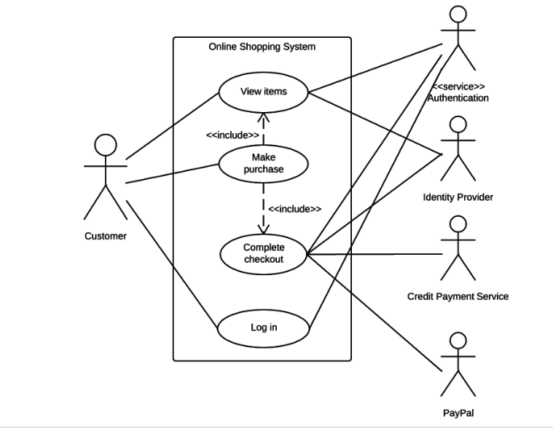

**FULLY DRESSED USECASE FOR => VIEW ITEMS**

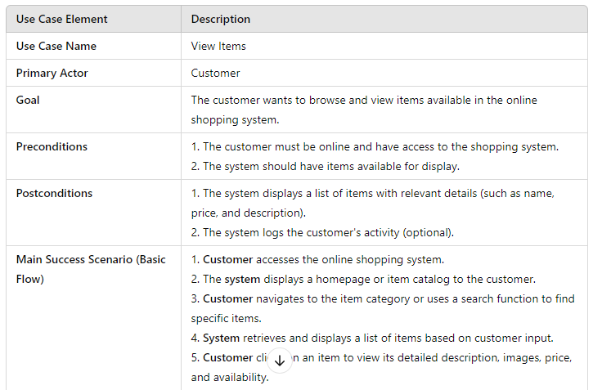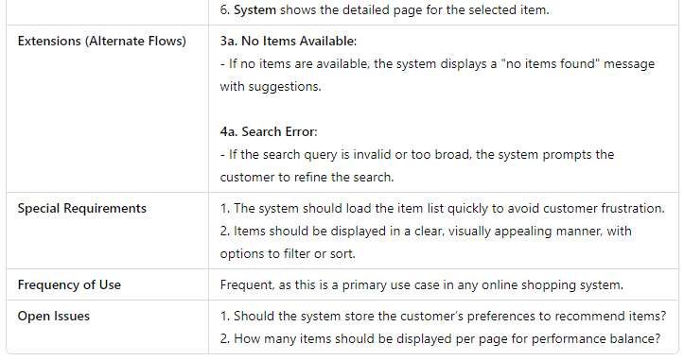

**SYSTEM SEQUENCE DIAGRAM**

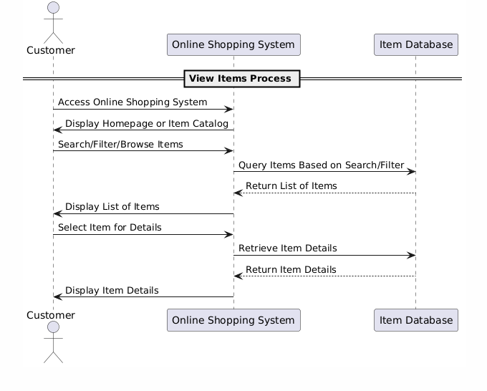

**COMMUNICATION DIAGRAM**

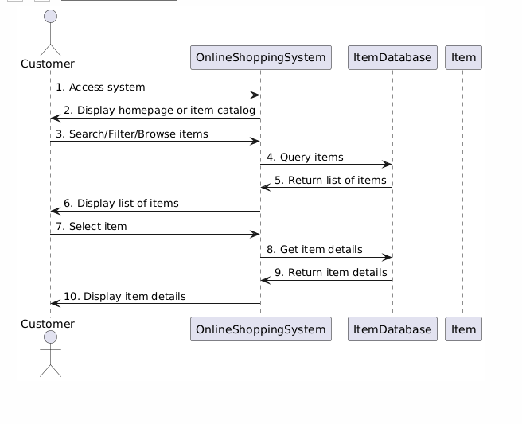

**CLASS DIAGRAM**

